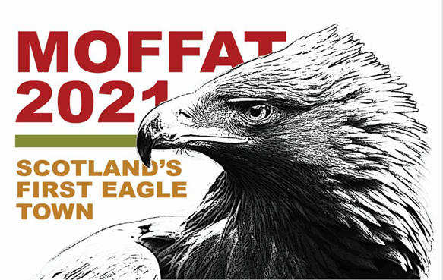

THE EAGLE HILL FELL RUN
SUNDAY 26TH SEPTEMBER, 10:00am
A just over 10k hill race in association with the following:
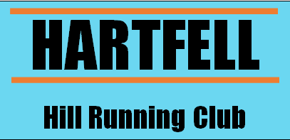

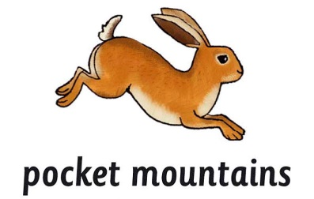
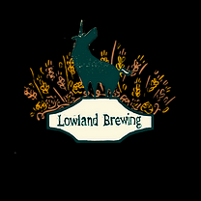
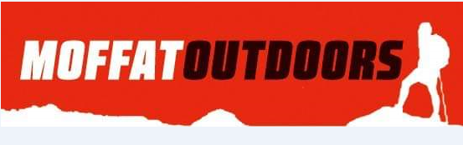

Enter online at: EntryCentral link. Cost £10:00
Event Venue: The Ram Statue in the Marketplace, Moffat
All Profits go to Moffat Mountain Rescue Team
A chance to win a magnificent trophy and the chance to name one of the young eagles released in 2021, all competitors will receive a limited-edition Eagle Pin Badge and an exclusive bottle of Golden Eagle Ale from Lowland Breweries, Lockerbie. There will be prizes for 1st, 2nd and 3rd place in all classes thanks to, Moffatoutdoors, Ambacare, and Pocket Mountains.
The race is around 6.4 miles and includes 1600ft of climbing off road, it is classed as a “BM” hill race run under a Scottish Hill Running classification, the minimum age for entry is 18 years on the day of the race.
The race is held under the rules, regulations, and insurance of Scottish Hill Runners.

Race Rules
- If you retire you must report to registration before you leave so we know you are safe.

- Full waterproof body cover including hat, gloves, whistle, map and compass must be carried at all times, to not do so would be a safety risk and would also be considered as having an unfair advantage over fellow runners.

- It is an open road event, beware of traffic.

- Do not litter, this will result in disqualification.

- Leave all gates as you find them, if you leave one open for a following runner make sure they do close it.

- Any course markings are for assistance only, carry the map provided, and be prepared to use it in the case of poor visibility or vandalism to the course markings.

- No Dogs.

Registration Form | Race Number:

Name
Club, if any
Phone Number
Email address
(For notification of prizes only)
Car registration Number
(In case of parking issue)

Tick the class you race in
Female  16 - 18 |  | Female Senior |  | F V40 |  | F V50 |  | F V60 |  | F V70 |  | FV80
Male  16 -18 |  | Male senior |  | M V40 |  | M V50 |  | M V60 |  | M V70 |  | MV80

Contact name In Case of Emergency | Phone number

DECLARATION:
I know that running is a potentially hazardous activity. I should not enter and run unless I am medically able and properly trained. I also know that, there could be traffic on the course route; therefore, I assume the risk of running in traffic. I also assume any other risks associated with running this event including, but not limited to, falls, contact with other participants, and the effects of weather and conditions of the course. I understand I am solely responsible for my own safety while travelling to and from or participating in this event. Knowing these facts and inconsideration of your acceptance of my entry, I hereby for myself, my heirs, executors, administrators, or anyone else who might sue on my behalf covenant not to sue, and waive, release, and discharge the sponsors or contributors to this event, any race officials, volunteers, the city and police agencies, their representatives successors or assignees from any and all claims of liability for death, personal injury, or property damage of any kind or nature whatsoever arising out of, or in the course of my participation. The release form and waiver extends to all claims of every kind or nature whatsoever, foreseen and unforeseen, known and unknown. The undersigned further grants full permission to use any photographs, video tapes, motion pictures, recordings, or another record of the event for any purpose.

Signed: Date:

